API Instance & Client Application Contracts

1. Creating an API instance on API Manager:
In API Manager 2.x, you can use instances of an API in multiple environments, and you can have multiple instances in the same environment. You can create one instance of an API that serves as a proxy. You can create another to manage directly as a basic endpoint. You can apply caching policies, for example to the proxy, and throttling policies and security policies to the basic endpoint.
After setting up an API version for management, you repeat the process to create another instance. Attempting to set up the same version creates another instance of the version. You can create multiple instances and expand the version information to view details about them:
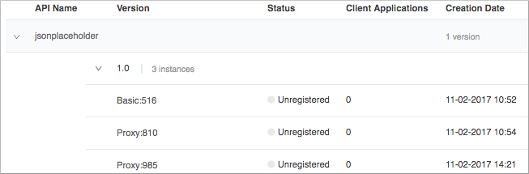

1. Set up an API to manage from Exchange.
For example, set up version 1.0 of an API named jsonplaceholder.
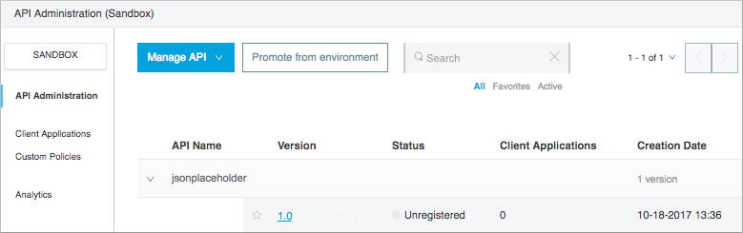
2. Repeat the process to set up an instance:
- In API Name, select the same API from Exchange, for example jsonplaceholder.
- In API Version, select the same version of the API, for example 1.0.
- In Asset Version, select the Exchange asset version.
- In Managing Type, choose Basic Endpoint or Endpoint with Proxy. For example, select Endpoint With Proxy.
- In Implementation URI, enter the URL that hosts your web site or an arbitrary URL, such as the example shown http://api.domain.com. An entry, any entry, is required if you chose Endpoint with Proxy. You cannot accept the default example; otherwise, saving this configuration is disabled.
- Select a proxy deployment target, for example CloudHub.
- Accept the default Path / for the proxy endpoint or enter another path.

3. Save, or optionally set advanced options, and then save.

4. In Advanced Options, optionally assign an instance label for the proxy, or accept the default label, and set a response timeout.

5. Return to the API administration dashboard: Click API Administration. In the Version column, the instance indicator appears beside the version name.

6. Expand the version.

2. Determining API Instance ID on API Manager:

API Manager generates the apiId of new APIs managed by API Manager for use with Mule 4. The API ID is displayed on the API instance dashboard if you select Mule 4 Runtime in the configuration of an API instance.
- On the API administration dashboard, expand the API version name to display the instances.

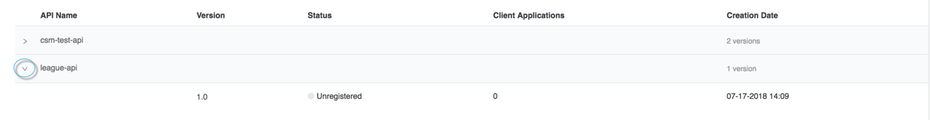
- Click an instance name.
The API ID appears:
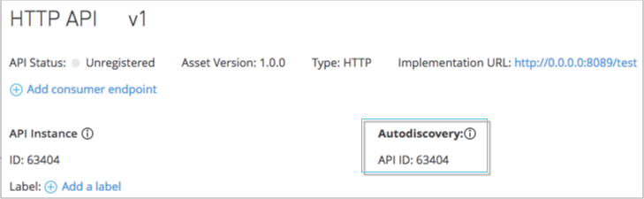
Note: The API ID is not available for Mule 3 use in API Manager.

3. API Instance Management in API Manager

In API Manager, you may also create, import, and deprecate API instances.
On the API administration dashboard, you expand the API version name to display the instances if there are any:
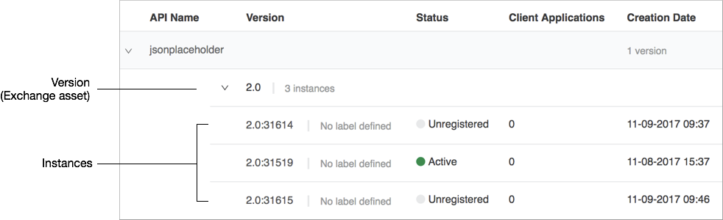

You can use instances of an API in multiple environments, and you can have multiple instances in the same environment. You can create one instance of an API that serves as a proxy. You can create another to manage directly as a basic endpoint. You can apply caching policies to the proxy, for example, and throttling policies and security policies to the basic endpoint. For more information about API instance management, see "About Basic API Management Tasks" link below.
In addition to API instance management in API Manager, you can perform other API management tasks. You can promote an API to another environment and configure an API endpoint, for example. (Promoting an API requires Manage APIs Configuration permission to be set for a user.)

4. Deprecating an API instance on API Manager:
While transitioning consumers of your API to an updated instance, you can prevent developers from signing up for access to your old API instance. As an API administrator, you mark an API as deprecated to remove the invitation for developers to request access from the portal page. Existing application contracts remain active but no new contracts can be created for that API instance. Deprecated APIs have an indicator in any location where they appear showing they are deprecated. A badge in search results indicates that the instance is deprecated.
- In Anypoint Platform, click API Manager.
- In API Administration, click the instance link.
- Select Deprecate from the Actions dropdown.
The Deprecate Version on Actions changes to Undeprecate Version.
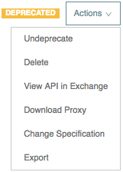

5. Removing an API instance on API Manager

The procedure removes the capability to manage an API Version from API Manager. If the API resides in Exchange or on the file system as a ZIP, it isn’t deleted from Exchange or the file system.
- In Anypoint Platform, click API Manager.
- In API Administration, click the API version link or an instance link.
- Select Delete from the Actions dropdown.
- Respond to the prompt to confirm the deletion. Click Delete.

Client Applications and Contracts

1. Managing API instance Contracts on API Manager
In API Manager, you can grant access to applications that want to consume your APIs by creating instance Contracts.
To view your API Instance contracts:
- In API Manager, click API Administration.
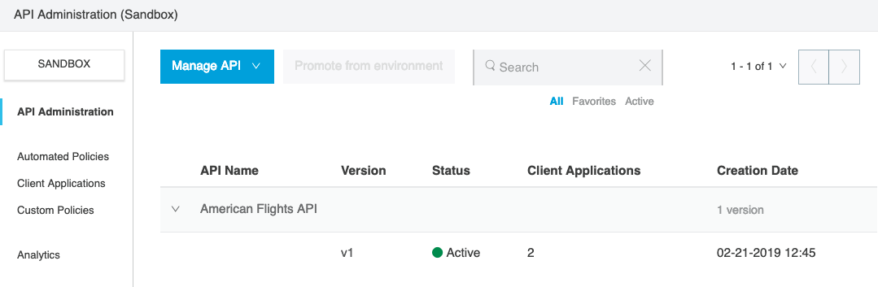
2. Click the API Name of your desired API instance.
3. Click the API Version of your selected API instance.
This opens the configuration page of your selected API instance.
4. Click Contracts from the left menu.
This tab displays information of every contract with your API instance, and a client application.
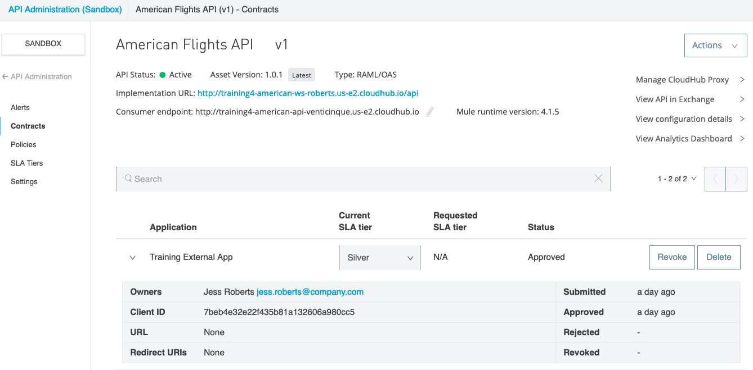
To manage your API Instance contracts:
- In API Manager, click Client Applications.
- Click the API Name of your desired API instance.
This tab displays information about the app, access controls for removing the app (revoking access), resetting the client ID and client secret, and adding or removing app owners:
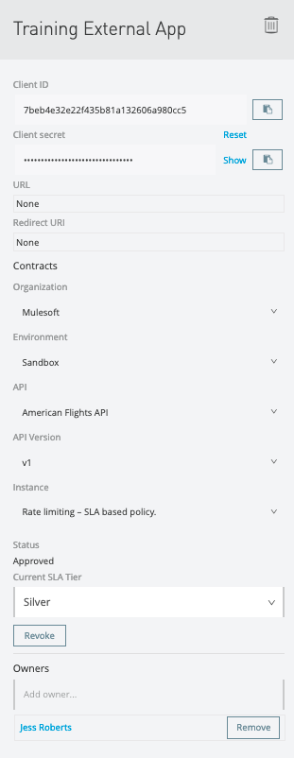

2. Getting Client ID and Client Secret of a registered Client App

As Organization Administrator of the master organization, after you approve a client app to access your API, you can access information about the app from API Manager > Contracts. You can view and reset the unique client ID and client secret for the application. When calling the API, the client app owner needs to pass these credentials if the API is protected with policies.

3. Removing API instance Contracts on API Manager

As Organization Administrator of the master organization, to delete an application that you gave access to your API:
- Click API Manager > Contracts.
- Select the name of the application to delete.
- Click Delete .
This action deletes any granted access to that contract from the API Exchange portal.

